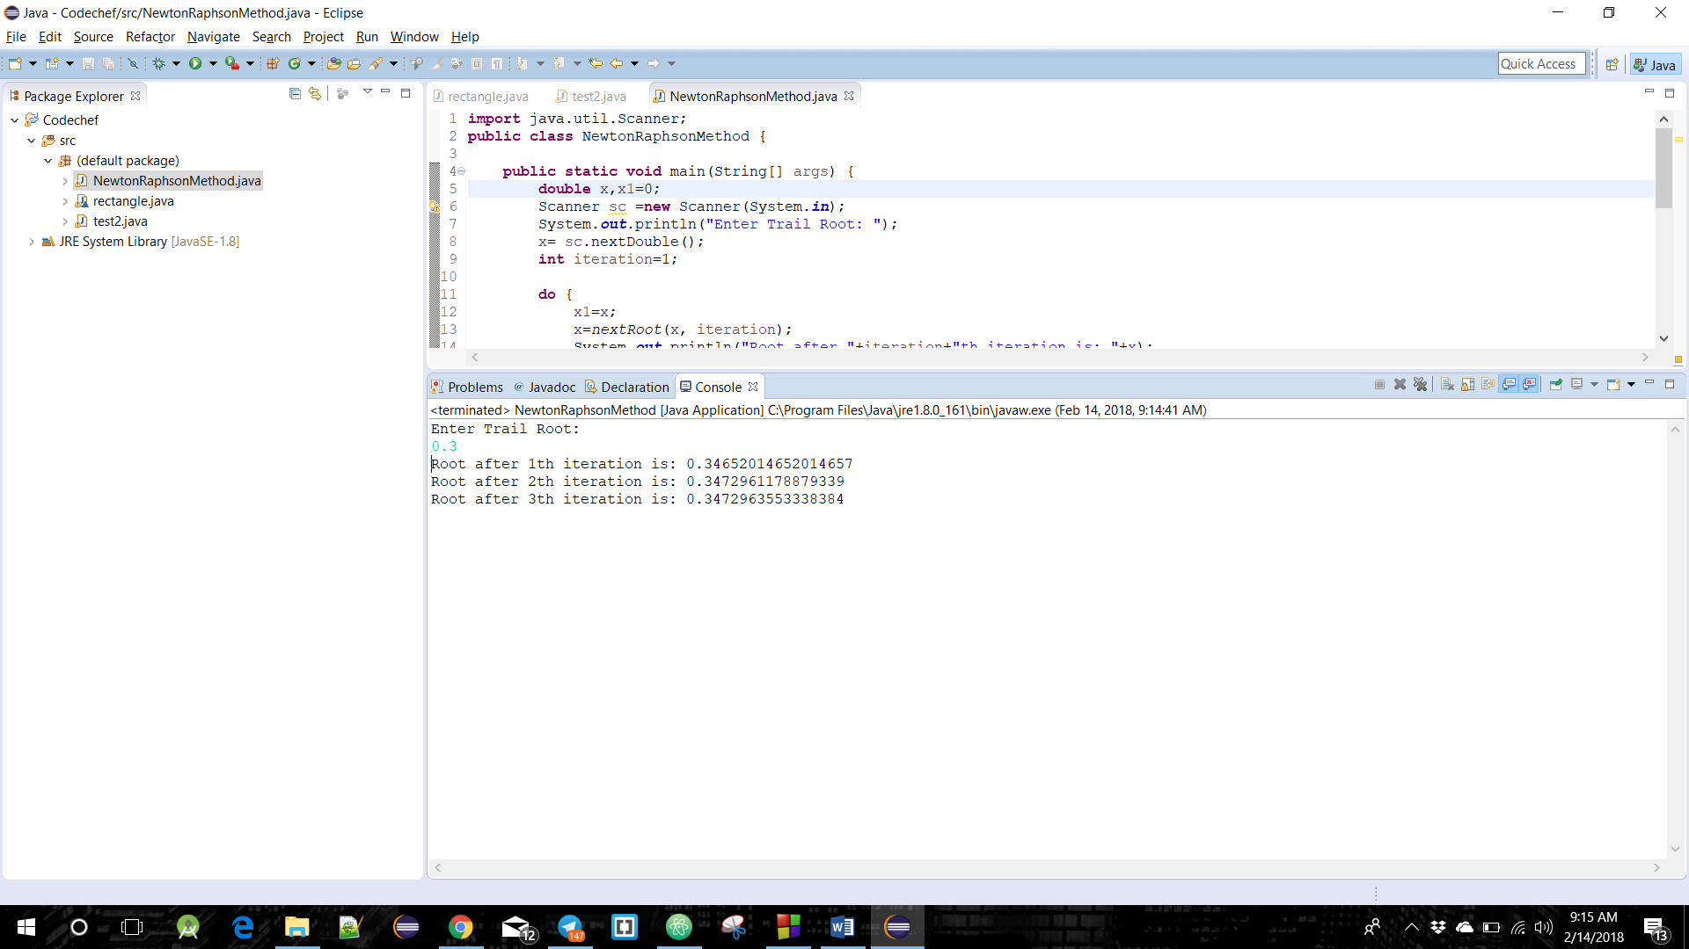

**Roots of f(x)=x3-3x+1 using Newton Raphson Method**

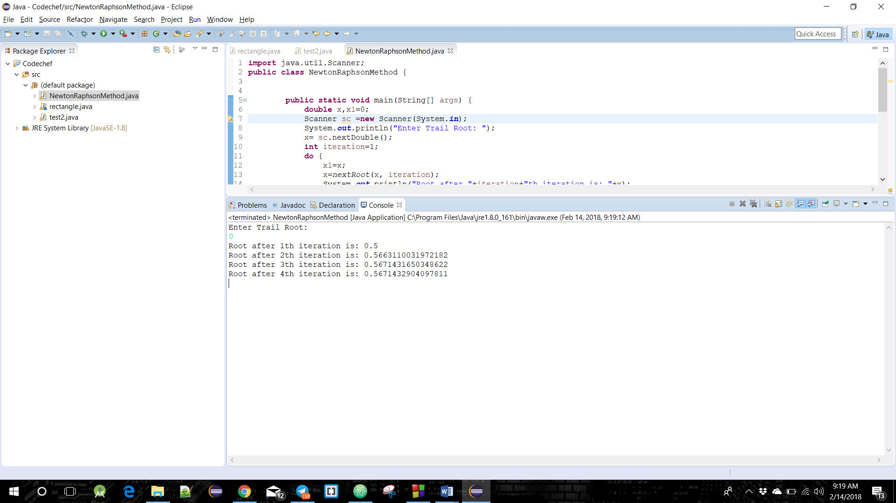

**Roots of f(x)= e-x-x using Newton Raphson Method**